**We would like to know more about your impressions of the 2014 International Conference of the System Dynamics Society in Delft, The Netherlands. For each of the following statements, please indicate your answer by selecting one of the options available. Most questions can be answered on a scale from 1 = very negative to 7 = very positive; no opinion.**



**#** **Answer** **Bar** **Response** **%**



|  |  |  |  |
| --- | --- | --- | --- |
|  | Total | 0 | 100.00% |
|  |  |  |  |

**When it comes to conference content my evaluation is:**



|  |  |  |  |  |  |  |  |  |  |  |  |  |
| --- | --- | --- | --- | --- | --- | --- | --- | --- | --- | --- | --- | --- |
|  | **#** | **Answer** |  |  |  |  |  | **Bar** | **Response** | **%** |  |  |
|  |  |  |  |  |  |  |  |
|  |  |  |  |  |  |  |  |  |  |  |  |  |
| 1 | | 1: very negative |  |  |  |  |  |  | 0 | 0.00% |  |  |
|  | |  |  |  |  |  |  |  |  |  |  |  |
| 2 | | 2 |  |  |  |  |  |  | 2 | 1.41% |  |  |
|  |  |  |  |  |  |  |  |
|  |  |  |  |  |  |  |  |  |  |  |  |  |
| 3 | | 3 |  |  |  |  |  |  | 8 | 5.63% |  |  |
|  |  |  |  |  |  |  |  |
|  |  |  |  |  |  |  |  |  |  |  |  |  |
| 4 | | 4 |  |  |  |  |  |  | 16 | 11.27% |  |  |
|  |  |  |  |  |  |  |  |
|  |  |  |  |  |  |  |  |  |  |  |  |  |
| 5 | | 5 |  |  |  |  |  |  | 27 | 19.01% |  |  |
|  |  |  |  |  |  |  |  |
|  |  |  |  |  |  |  |  |  |  |  |  |  |
| 6 | | 6 |  |  |  |  |  |  | 51 | 35.92% |  |  |
|  |  |  |  |  |  |  |  |
|  |  |  |  |  |  |  |  |  |  |  |  |  |
| 7 | | 7: very positive |  |  |  |  |  |  | 38 | 26.76% |  |  |
|  |  |  |  |  |  |  |  |
|  |  |  |  |  |  |  |  |  |  |  |  |  |
| 8 | | no opinion |  |  |  |  |  |  | 0 | 0.00% |  |  |
|  |  | Total |  |  |  |  |  |  | 142 | 100.00% |  |  |
|  |  |  |  |  |  |  |  |  |  |
|  |  |  |  |  |  |  |  |  |  |  |  |  |



**Additional comments**



**Text Entry**



 Weel organised and the breakout sessions impactful

 Great variety of issues and of methodological sessions as well.

 I was slightly disappointed by the number of academic(masters and PhD students) and less practitioners.

 can we please record presentations so they can be shared with others

As always, there is a struggle between encouraging participation (including among students) and delivering high quality content.

There were many good presentations, however I think that the presentations for the big sessions were not adequately chosen. Particularly the ones for the clossing session... Perhaps there wasn't enough revision by the chairs of the papers and it seems there wasn't previous contact between the chairs and the presentors. Presentations for this session were defficient in content and presentation wise.

One must always strike a balance between more "academic" papers and more policy oriented ones. Personally, I lean toward the latter. The presentations in the last plenary session were a great example of papers from which I get the most.

My interest is in the teaching and learning of system dynamics. There were so few presentations (only one parallel session) that it seemed as if that thread was an afterthought. If we want to spread the SD method, to have more decision- makers use this analytical approach, it seems as if a teaching and learning thread should be strong (and present) throughout each ISD Conference.

I discovered the conference to be extremely informative and very well organized. The one issue that appears to be lacking in presentations I observed throughout the sessions was the focus on methodology. More often than not it appears that single models are presented, or just the CLDs, without much attention given to the back- end methodological analyses involving sensitivity, validation, or assessment of errors. I did discover much value in papers presented in the methodology sessions and believe much more attention ought to be directed toward the presentation of methodological analyses capable of informing the meaningfulness of those substantive findings presented.

 Some good parallels, some boring ones as always.

**View More**

**When it comes to the services provided by the conference organization my evaluation is:**



* **Answer**
* 1: very negative

2 2

3 3

4 4

5 5

6 6

* 7: very positive

8no opinion

Total

**Bar** **Response** **%**

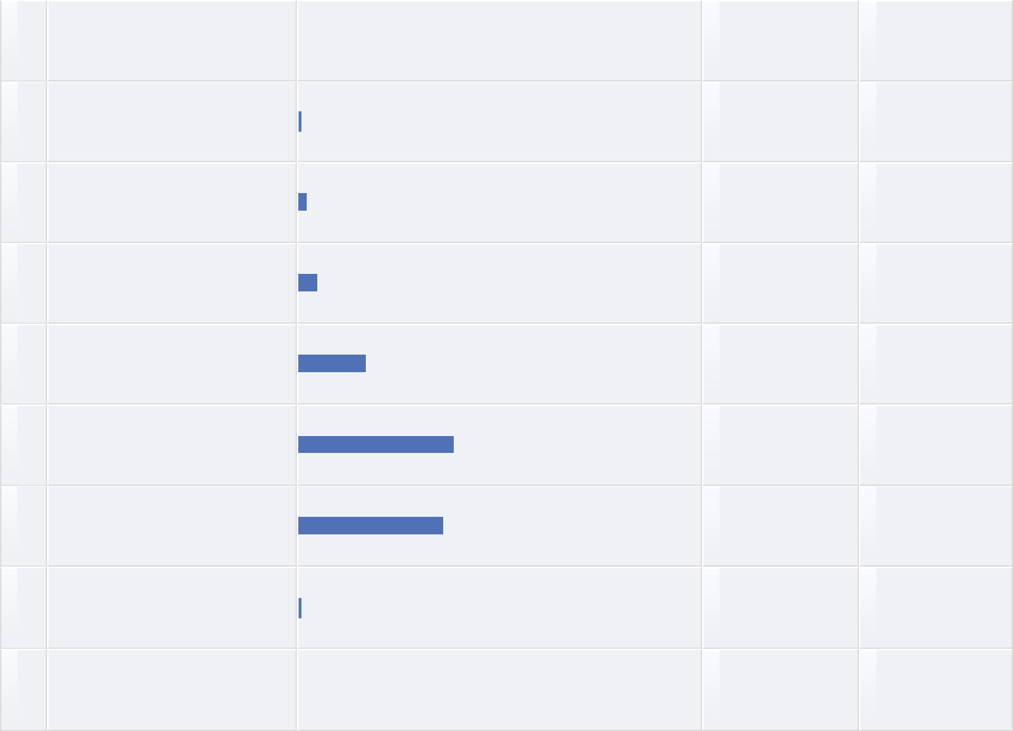

0 0.00%

1 0.70%

3 2.11%

7 4.93%

24 16.90%

55 38.73%

51 35.92%

1 0.70%

142 100.00%

**Additional comments**



**Text Entry**



The on-site food was not always great (Tuesday lunch was the low point).

General organization and amount of information provided very good. However, sessions planned in breaks and lunch time were difficult to attend, so maybe at least at Lunchtime it would be better not to plan them the first half hour, but the second half hour. The videotaping and streaming of content such as the Business SIG meeting are very helpful in that case as well.

Improve on the lunch provisions.

The services were excellent - as always. I didn't much care for the lunches however. I would prefer the lighter fare that was offered for the PhD colloquium.

the boat ride was a really nice touch.

Some key items like bell ringing were missed.

My only problem with the conference organization was the lunch served. It was really poor compared to other services provided in the organization. Same was probably true for the conference dinner too.

I am not sure what "services" mean exactly.

Could not find rooms easily. More water stations on hot days. Transport to and from hotels was needed.

Lunch was not good value for money.

**View More**

**When it comes to conference geographical location my evaluation is:**



* **Answer**
* 1: very negative

2 2

3 3

4 4

5 5

6 6

* 7: very positive

8no opinion

Total

**Bar** **Response** **%**

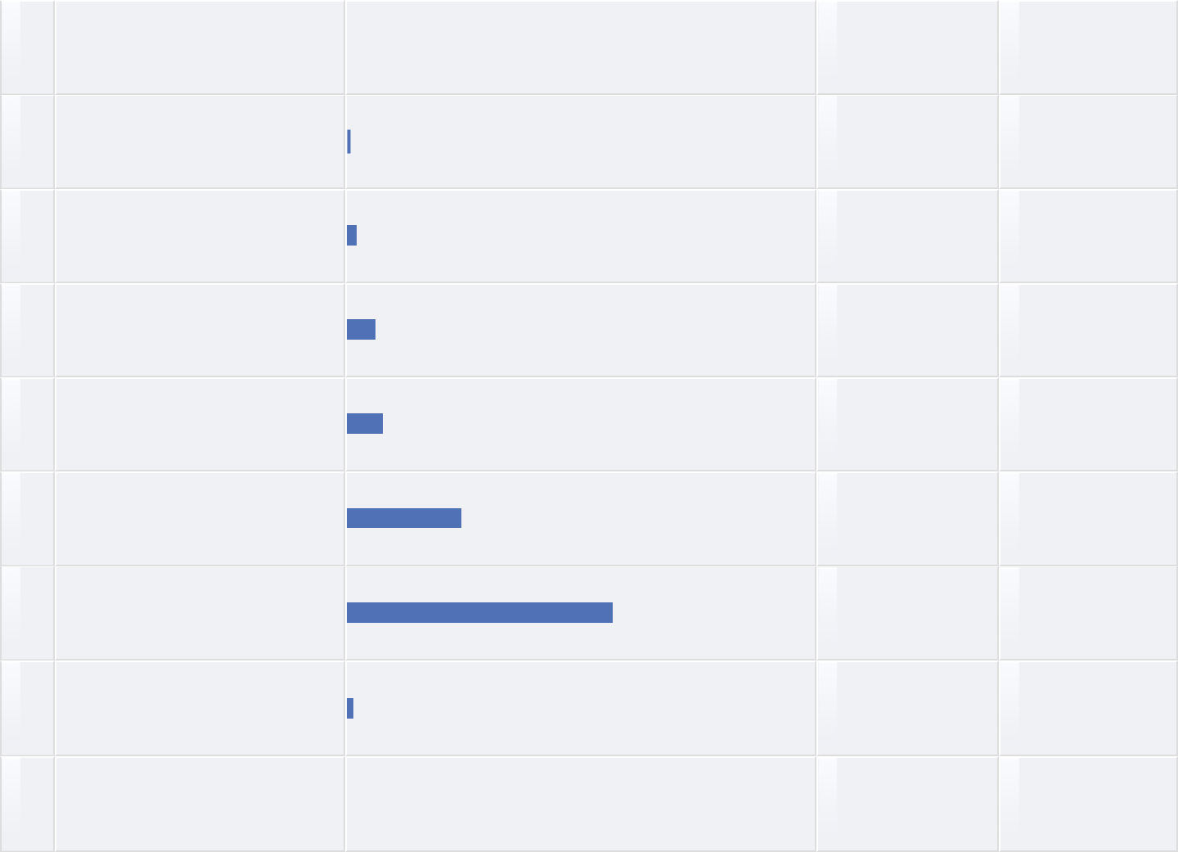

0 0.00%

1 0.70%

3 2.11%

9 6.34%

11 7.75%

35 24.65%

81 57.04%

2 1.41%

142 100.00%

**Additional comments**



**Text Entry**



Satisfactory

Netherlands is easy to reach from everywhere in Europe and especially easy to reach by public transport. Delft is also a great city since it is small, so everything is in walkable distance and it is easy to find groups for spending time with participants after the official programme. Nice to end one of the days in Rotterdam as well.

lovely city, very convenient

Delft was a great area, calm and sedate, away from the everyday rush of the big cities

I loved the Delft site, especially the daily walks to and from the conference venue. The Hampshire hotel was ideal.

Access map should be provided.

Lovely venue in a lovely town so on a personal level it was fantastic. The venue itself was fully appropriate for requirements so on a functional level it was equally fantastic.

Delft was lovely, easy to access.

Delft is a nice place.

Delft is a great place and easy for me to reach.

**View More**

**When it comes to the conference venue (building and facilities) my evaluation is:**



|  |  |  |  |  |  |  |  |  |  |  |  |  |
| --- | --- | --- | --- | --- | --- | --- | --- | --- | --- | --- | --- | --- |
|  | **#** | **Answer** |  |  |  |  |  | **Bar** | **Response** | **%** |  |  |
|  |  |  |  |  |  |  |  |
|  |  |  |  |  |  |  |  |  |  |  |  |  |
| 1 | | 1: very negative |  |  |  |  |  |  | 2 | 1.41% |  |  |
|  |  |  |  |  |  |  |  |
|  |  |  |  |  |  |  |  |  |  |  |  |  |
| 2 | | 2 |  |  |  |  |  |  | 0 | 0.00% |  |  |
|  | |  |  |  |  |  |  |  |  |  |  |  |
| 3 | | 3 |  |  |  |  |  |  | 6 | 4.23% |  |  |
|  |  |  |  |  |  |  |  |
|  |  |  |  |  |  |  |  |  |  |  |  |  |
| 4 | | 4 |  |  |  |  |  |  | 12 | 8.45% |  |  |
|  |  |  |  |  |  |  |  |
|  |  |  |  |  |  |  |  |  |  |  |  |  |
| 5 | | 5 |  |  |  |  |  |  | 20 | 14.08% |  |  |
|  |  |  |  |  |  |  |  |
|  |  |  |  |  |  |  |  |  |  |  |  |  |
| 6 | | 6 |  |  |  |  |  |  | 45 | 31.69% |  |  |
|  |  |  |  |  |  |  |  |
|  |  |  |  |  |  |  |  |  |  |  |  |  |
| 7 | | 7: very positive |  |  |  |  |  |  | 57 | 40.14% |  |  |
|  |  |  |  |  |  |  |  |
|  |  |  |  |  |  |  |  |  |  |  |  |  |
| 8 | | no opinion |  |  |  |  |  |  | 0 | 0.00% |  |  |
|  |  | Total |  |  |  |  |  |  | 142 | 100.00% |  |  |
|  |  |  |  |  |  |  |  |  |  |
|  |  |  |  |  |  |  |  |  |  |  |  |  |



**Additional comments**



**Text Entry**



Good not to spread it out to more than two buildings. In general, rooms easy enough to find.

The size of the main auditorium dwarfed the attendence, making it seem like few people were there.

plenty of space, just not easy to find your way around

TU Delft is a great venue. Within easy walking/cycling distance of most hotels.

The main venue was what it was, but I - and others too - found it an extraordinarily difficulty building to negotiate. I think better signage would help. I liked the the way the posters were spread throughout the venue (in contrast to Cambridge) which make it easy to view them without crowding.

see above

The lack of AC the first days was brutal.

No one seemed to look at the weather report. The entire conference venue was humid. The Air conditioning was not turned on until the day of the conference it made it hard to think and hard to want to be in the venue. The building was alright, however I got lost several times. There needed to be more signage about where to go in the building. There were few hotels near the venue.

Did expect easier access to services like printing, etc. given the high fees for the conference.

A geart venue

**View More**

**When it comes to conference social activities (such as welcome reception, dinner and spouse activities) my evaluation is:**



**#** **Answer** **Bar** **Response** **%**



* 1: very negative
* 0.70%

2 2

* 0.70%

|  |  |  |  |  |  |  |  |  |  |  |
| --- | --- | --- | --- | --- | --- | --- | --- | --- | --- | --- |
| 3 | 3 |  | 3 | | | | | | 2.11% |  |
|  |  |
|  |  |  |  |  |  |  |  |  |  |  |
| 4 | 4 |  | |  | 11 | | | | 7.75% |  |
|  | |  |  |
|  |  |  |  |  |  |  |  |  |  |  |
| 5 | 5 |  | |  | | 20 | | | 14.08% |  |
|  | |  | |  |
|  |  |  |  |  |  |  |  |  |  |  |
| 6 | 6 |  | |  | | | 37 | | 26.06% |  |
|  | |  | | |  |
|  |  |  |  |  |  |  |  |  |  |  |
| 7 | 7: very positive |  | |  | | | | 61 | 42.96% |  |
|  | |  | | | |  |
|  |  |  |  |  |  |  |  |  |  |  |
| 8 | no opinion |  | | 8 | | | | | 5.63% |  |
|  | |  |
|  | Total | 142 | | | | | | | 100.00% |  |
|  |  |
|  |  |  |  |  |  |  |  |  |  |  |

**Additional comments**



**Text Entry**



A nice and warm reception, dinner was satisfactory.

The dinner on de Majesteit was exceptional

the boat trip was great

The boat trip was lovely, as were the various receptions.

There were some excellent spouse activities. Other events such as the reception and the harbour-cruise banquet were enjoyable.

In future years, I replace the boat trip with a more traditional banquet format in which awards are given. The boat trip tended to isolate participants into small groups, the drinks were expensive (including two Euros for a glass of water, as I recall) and the food was mediocre.

Not enough time to enjoy everything :)

All of this was very nice. I felt that we were very welcomed by the SDS and the TU team!

Good dinner, shame we had to spread the awards out, but it was easier to move about than a normal conference dinner.

My wife was very satisfied with the spouse lounge activities (thanks to the organizers). However, the conference dinner was well below our expectations. We could not find much to eat. My rating would be higher otherwise.

**View More**

**When it comes to overall value my evaluation is:**



|  |  |  |  |  |  |  |  |  |  |  |  |  |
| --- | --- | --- | --- | --- | --- | --- | --- | --- | --- | --- | --- | --- |
|  | **#** | **Answer** |  |  |  |  |  | **Bar** | **Response** | **%** |  |  |
|  |  |  |  |  |  |  |  |
|  |  |  |  |  |  |  |  |  |  |  |  |  |
| 1 | | 1: very negative |  |  |  |  |  |  | 0 | 0.00% |  |  |
|  | |  |  |  |  |  |  |  |  |  |  |  |
| 2 | | 2 |  |  |  |  |  |  | 0 | 0.00% |  |  |
|  | |  |  |  |  |  |  |  |  |  |  |  |
| 3 | | 3 |  |  |  |  |  |  | 4 | 2.90% |  |  |
|  |  |  |  |  |  |  |  |
|  |  |  |  |  |  |  |  |  |  |  |  |  |
| 4 | | 4 |  |  |  |  |  |  | 10 | 7.25% |  |  |
|  |  |  |  |  |  |  |  |
|  |  |  |  |  |  |  |  |  |  |  |  |  |
| 5 | | 5 |  |  |  |  |  |  | 25 | 18.12% |  |  |
|  |  |  |  |  |  |  |  |
|  |  |  |  |  |  |  |  |  |  |  |  |  |
| 6 | | 6 |  |  |  |  |  |  | 58 | 42.03% |  |  |
|  |  |  |  |  |  |  |  |
|  |  |  |  |  |  |  |  |  |  |  |  |  |
| 7 | | 7: very positive |  |  |  |  |  |  | 41 | 29.71% |  |  |
|  |  |  |  |  |  |  |  |
|  |  |  |  |  |  |  |  |  |  |  |  |  |
| 8 | | no opinion |  |  |  |  |  |  | 0 | 0.00% |  |  |
|  |  | Total |  |  |  |  |  |  | 138 | 100.00% |  |  |
|  |  |  |  |  |  |  |  |  |  |
|  |  |  |  |  |  |  |  |  |  |  |  |  |



**Additional comments**



**Text Entry**



satisfactory

Networking opportunities and learning what people are doing!

Great open atmosphere that enables an easy way of finding contacts, especially with all the SIG, newcomer etc.

ribbons.

The value is based more on networking than in anything else. But the conference should delivere more than that.

I always love the conferences, whatever shortcomings there may be.

see comments regarding facilities

the lunch was fantasic most days. Dissapointing that one day the lunch was sausage rolls.

Unfortunately, the feedback from the reviews and in the presentations were not really what I havee expected

It is an expensive conference, with travel, lodging and registration, as well as membership.

Would pay again.

**View More**

**When it comes to the conference fee my evaluation is:**



|  |  |  |  |  |  |  |  |  |  |  |  |  |
| --- | --- | --- | --- | --- | --- | --- | --- | --- | --- | --- | --- | --- |
|  | **#** | **Answer** |  |  |  |  |  | **Bar** | **Response** | **%** |  |  |
|  |  |  |  |  |  |  |  |
|  |  |  |  |  |  |  |  |  |  |  |  |  |
| 1 | | 1: too expensive |  |  |  |  |  |  | 5 | 3.65% |  |  |
|  |  |  |  |  |  |  |  |
|  |  |  |  |  |  |  |  |  |  |  |  |  |
| 2 | | 2 |  |  |  |  |  |  | 7 | 5.11% |  |  |
|  |  |  |  |  |  |  |  |
|  |  |  |  |  |  |  |  |  |  |  |  |  |
| 3 | | 3 |  |  |  |  |  |  | 14 | 10.22% |  |  |
|  |  |  |  |  |  |  |  |
|  |  |  |  |  |  |  |  |  |  |  |  |  |
| 4 | | 4 |  |  |  |  |  |  | 25 | 18.25% |  |  |
|  |  |  |  |  |  |  |  |
|  |  |  |  |  |  |  |  |  |  |  |  |  |
| 5 | | 5 |  |  |  |  |  |  | 21 | 15.33% |  |  |
|  |  |  |  |  |  |  |  |
|  |  |  |  |  |  |  |  |  |  |  |  |  |
| 6 | | 6 |  |  |  |  |  |  | 34 | 24.82% |  |  |
|  |  |  |  |  |  |  |  |
|  |  |  |  |  |  |  |  |  |  |  |  |  |
| 7 | | 7: very reasonable |  |  |  |  |  |  | 25 | 18.25% |  |  |
|  |  |  |  |  |  |  |  |
|  |  |  |  |  |  |  |  |  |  |  |  |  |
| 8 | | no opinion |  |  |  |  |  |  | 6 | 4.38% |  |  |
|  |  |  |  |  |  |  |  |
|  |  | Total |  |  |  |  |  |  | 137 | 100.00% |  |  |
|  |  |  |  |  |  |  |  |  |  |
|  |  |  |  |  |  |  |  |  |  |  |  |  |



**Additional comments**



**Text Entry**



One of the more expensive conferences I have been too as a student, but the concrete value provided makes up for it. One of the more useful conferences I have been to compared to quite a lot others.

It is high.

The registration is too expensive. Should be more sustainable especially for who also has too pay flights, hotel, etc.

Except for the food

Lunch bad quality

Lunch package could be cheaper or done in another way.

Volunteer

**When it comes to the hotel sleeping accommodation my evaluation is:**



|  |  |  |  |  |  |  |  |  |  |  |  |  |
| --- | --- | --- | --- | --- | --- | --- | --- | --- | --- | --- | --- | --- |
|  | **#** | **Answer** |  |  |  |  |  | **Bar** | **Response** | **%** |  |  |
|  |  |  |  |  |  |  |  |
|  |  |  |  |  |  |  |  |  |  |  |  |  |
| 1 | | 1: very negative |  |  |  |  |  |  | 3 | 2.17% |  |  |
|  |  |  |  |  |  |  |  |
|  |  |  |  |  |  |  |  |  |  |  |  |  |
| 2 | | 2 |  |  |  |  |  |  | 3 | 2.17% |  |  |
|  |  |  |  |  |  |  |  |
|  |  |  |  |  |  |  |  |  |  |  |  |  |
| 3 | | 3 |  |  |  |  |  |  | 5 | 3.62% |  |  |
|  |  |  |  |  |  |  |  |
|  |  |  |  |  |  |  |  |  |  |  |  |  |
| 4 | | 4 |  |  |  |  |  |  | 10 | 7.25% |  |  |
|  |  |  |  |  |  |  |  |
|  |  |  |  |  |  |  |  |  |  |  |  |  |
| 5 | | 5 |  |  |  |  |  |  | 15 | 10.87% |  |  |
|  |  |  |  |  |  |  |  |
|  |  |  |  |  |  |  |  |  |  |  |  |  |
| 6 | | 6 |  |  |  |  |  |  | 31 | 22.46% |  |  |
|  |  |  |  |  |  |  |  |
|  |  |  |  |  |  |  |  |  |  |  |  |  |
| 7 | | 7: very positive |  |  |  |  |  |  | 35 | 25.36% |  |  |
|  |  |  |  |  |  |  |  |
|  |  |  |  |  |  |  |  |  |  |  |  |  |
| 8 | | no opinion |  |  |  |  |  |  | 36 | 26.09% |  |  |
|  |  |  |  |  |  |  |  |
|  |  | Total |  |  |  |  |  |  | 138 | 100.00% |  |  |
|  |  |  |  |  |  |  |  |  |  |
|  |  |  |  |  |  |  |  |  |  |  |  |  |



**Please indicate the name of your hotel and any additional comments you would like to make**



**Text Entry**



satisfactory

not used - might recommend students to use AirBNB at future conferences to save costly hotel charges

Westcord Hotel Delft is a good business hotel, but I would have enjoyed the charm of the older and smaller hotels more. Althoough the hotel is basically a bed to sleep in and for breakfast, the rest of the time at the conference is busy.

Westcord, Delft

I took AirBnB service.

Leuenberg

Campanile Hotel Delft ; clean, reasonably priced; good food; excellent service; free access to conference area for presentation preparation. Distance from conference facility gave me an opportunity to explore all areas of Delft.

Emauspoort

Grand Canal Station. Small, clean, convenient.

Hampshire hotel, loved my stay there.

**View More**

**When it comes to the printed abstract proceedings for use at the conference my evaluation is:**



* **Answer**
* 1: not needed

2 2

3 3

4 4

5 5

6 6

* 7: very useful

8no opinion Total

**Bar** **Response** **%**

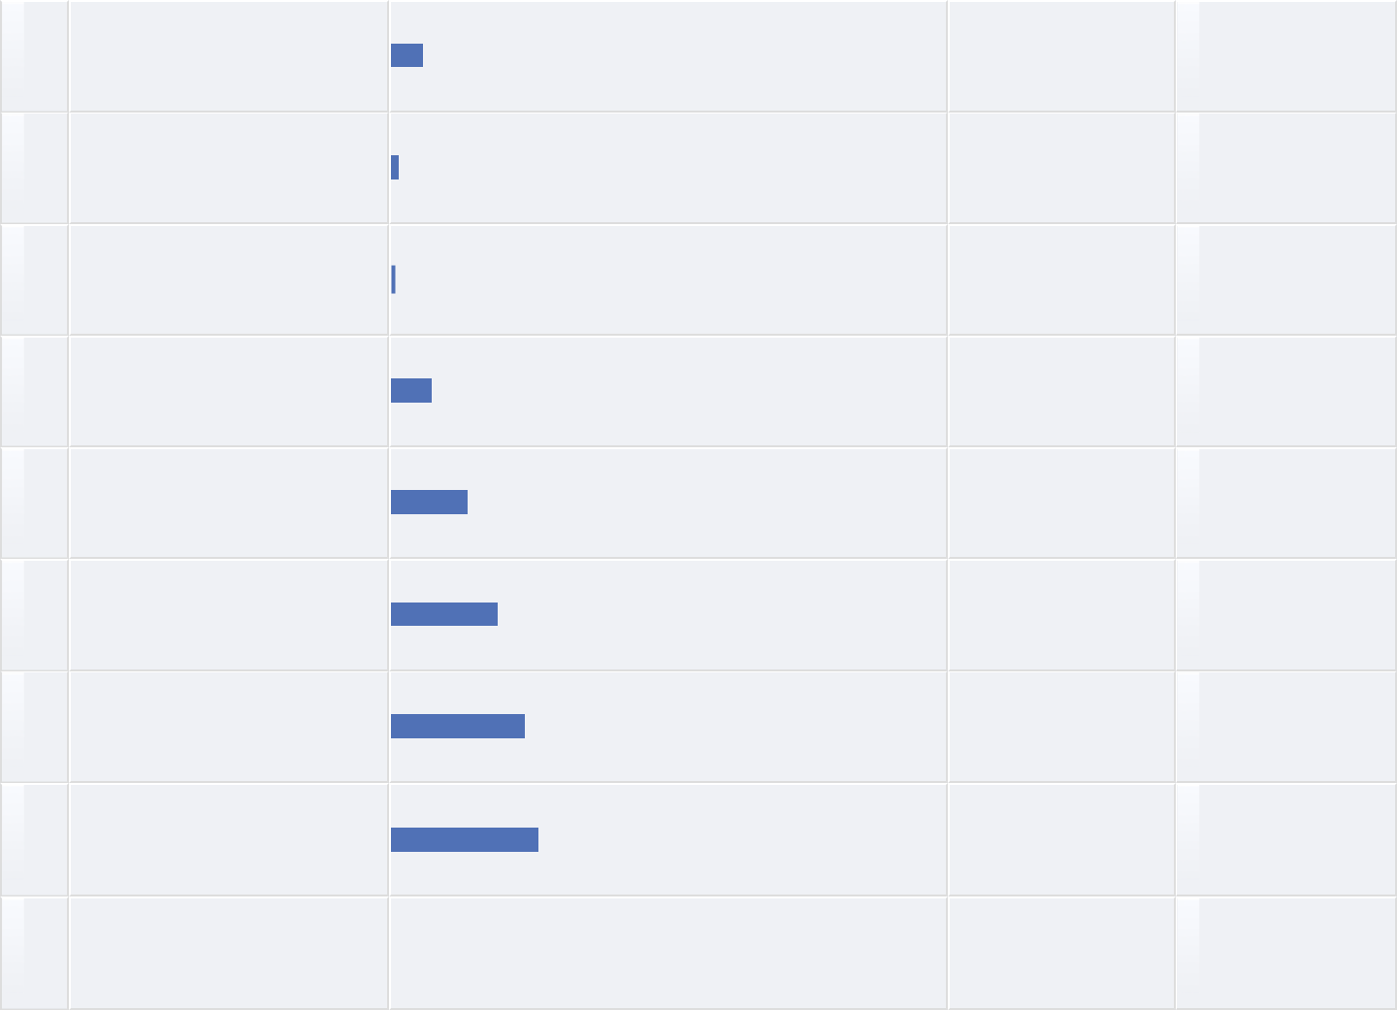

8 5.93%

2 1.48%

1 0.74%

10 7.41%

19 14.07%

26 19.26%

33 24.44%

36 26.67%

135 100.00%

**Additional comments**



**Text Entry**



adequate

Especially better than the endless scrolling at the tentative schedule at the website, where it's difficult to find anything.

Since the on-line version was readily available (free wireless), it wasn't as important as in Cambridge last year.

On line is fine with me.

I did not have printed abstract proceedings in my satchel. I did not know they were available. It would have been nice to have such a booklet.

it would be great to have access to full presentations and models for each presented case.

not particularly useful; could be managed on-line.

Useful for decisions which parallels to visit but a lot of paper...

don't need them. put abstracts online; people can view them on their phones/tablets/laptops

Useful but I used the online abstracts and information through wi-fi connection.

**View More**

**When it comes to the satchel my evaluation is:**



|  |  |  |  |  |  |  |  |  |  |  |  |  |
| --- | --- | --- | --- | --- | --- | --- | --- | --- | --- | --- | --- | --- |
|  | **#** | **Answer** |  |  |  |  |  | **Bar** | **Response** | **%** |  |  |
|  |  |  |  |  |  |  |  |
|  |  |  |  |  |  |  |  |  |  |  |  |  |
| 1 | | 1: not needed |  |  |  |  |  |  | 13 | 9.42% |  |  |
|  |  |  |  |  |  |  |  |
|  |  |  |  |  |  |  |  |  |  |  |  |  |
| 2 | | 2 |  |  |  |  |  |  | 5 | 3.62% |  |  |
|  |  |  |  |  |  |  |  |
|  |  |  |  |  |  |  |  |  |  |  |  |  |
| 3 | | 3 |  |  |  |  |  |  | 6 | 4.35% |  |  |
|  |  |  |  |  |  |  |  |
|  |  |  |  |  |  |  |  |  |  |  |  |  |
| 4 | | 4 |  |  |  |  |  |  | 13 | 9.42% |  |  |
|  |  |  |  |  |  |  |  |
|  |  |  |  |  |  |  |  |  |  |  |  |  |
| 5 | | 5 |  |  |  |  |  |  | 28 | 20.29% |  |  |
|  |  |  |  |  |  |  |  |
|  |  |  |  |  |  |  |  |  |  |  |  |  |
| 6 | | 6 |  |  |  |  |  |  | 25 | 18.12% |  |  |
|  |  |  |  |  |  |  |  |
|  |  |  |  |  |  |  |  |  |  |  |  |  |
| 7 | | 7: very useful |  |  |  |  |  |  | 30 | 21.74% |  |  |
|  |  |  |  |  |  |  |  |
|  |  |  |  |  |  |  |  |  |  |  |  |  |
| 8 | | no opinion |  |  |  |  |  |  | 18 | 13.04% |  |  |
|  |  |  |  |  |  |  |  |
|  |  | Total |  |  |  |  |  |  | 138 | 100.00% |  |  |
|  |  |  |  |  |  |  |  |  |  |
|  |  |  |  |  |  |  |  |  |  |  |  |  |



**Additional comments**



**Text Entry**



Useful

Used my own bag at the conference, added it to the collection at home.

tricky - I see some may find it useful but otherwise it's a waste

I intended to take participation in satcheling but I couldn't make it due to airplane schedule. I am very sorry for that.

Some participants love the satchels, but I would make them optional. I carry a back pack with mu computer and prefer to keep my conference materials in that.

okay; dump the brief case for a shoulder bag

Very useful, I like it

This was a lifesaver!

let's save $ and eliminate these. everyone comes to the conference with some sort of bag/pack already. most of the satchels end up useless in a closet or landfill. let's be more sustainable and cut costs at the same time.

Good bag and everything we needed.

**View More**

**When it comes to the lunch provided onsite my evaluation is:**



* **Answer**
* 1: not needed

2 2

3 3

4 4

5 5

6 6

* 7: very useful

8no opinion Total

**Bar** **Response** **%**

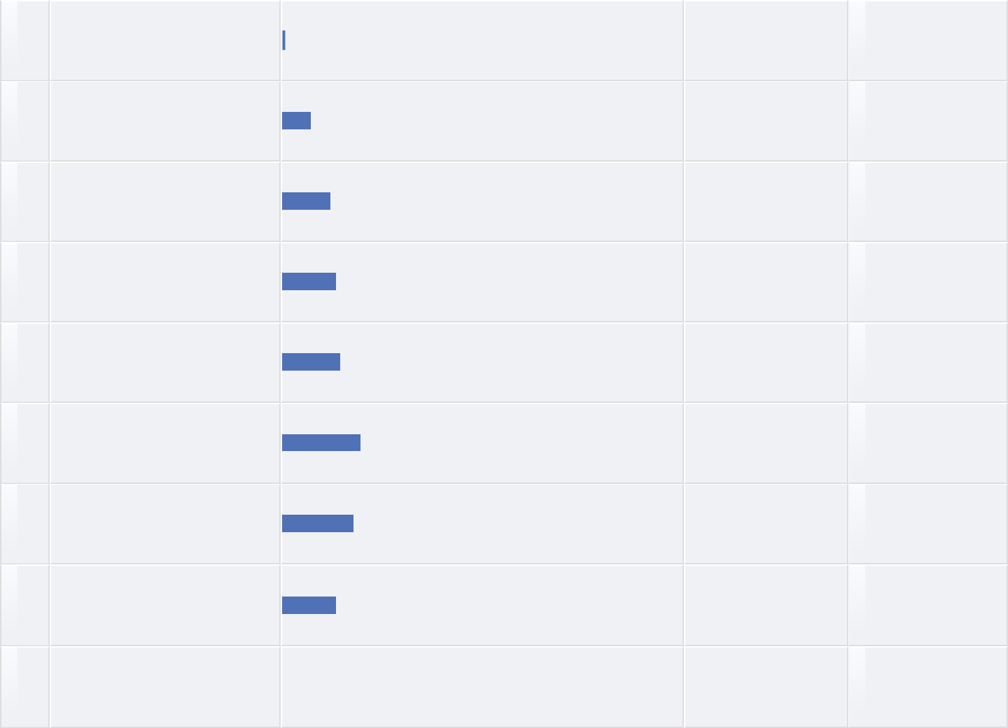

1 0.72%

10 7.25%

17 12.32%

19 13.77%

20 14.49%

27 19.57%

25 18.12%

19 13.77%

138 100.00%

**Additional comments**



**Text Entry**



Improve on lunch provision.

Good, but vegetarian option could have been marked clearer. Also organic and fair sourcing would be great to prefer and promote in the next years.

Some days were better than others. The pizza and pies did not do it for me.

As already stated, the lunch was only so-so and Tuesday was a real low.

For 15€ I was expecting a little more...

See my comments above on this. I like the lunch provided at the Ph.D. Colloquium.

I liked the salads. The hot food seemed to contain too much pasta and cream -based dishes for my preference. It was convenient to have the lunch served in three or four different locations in Aula. I also thought 15 euros was a pretty steep price for the lunch provided.

okay; while my special needs were met, preparation of special meals always took quite long.

the lunch was fantasic most days. Disappointing that one day the lunch was sausage rolls.

15 euros for a very limited choice menu was excessive...

**View More**

**The following questions concern the plenary sessions.**



**#** **Answer** **Bar** **Response** **%**



|  |  |  |  |
| --- | --- | --- | --- |
|  | Total | 0 | 100.00% |
|  |  |  |  |

**Are the plenary sessions too short or too long?**



* **Answer**
* 1: much too short

2 2

3 3

4 4

5 5

6 6

* 7: much too long

8no opinion

Total

**Bar** **Response** **%**

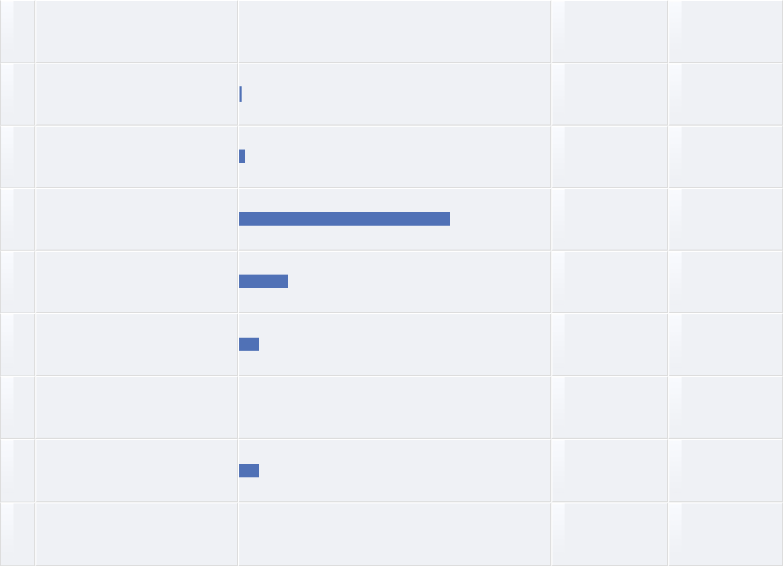

0 0.00%

1 0.73%

3 2.19%

93 67.88%

22 16.06%

9 6.57%

0 0.00%

9 6.57%

137 100.00%

**Should we have more or fewer plenary sessions?**



* **Answer**
* 1: fewer

2 2

3 3

4 4

5 5

6 6

* 7: more
* no opinion Total

**Bar** **Response** **%**

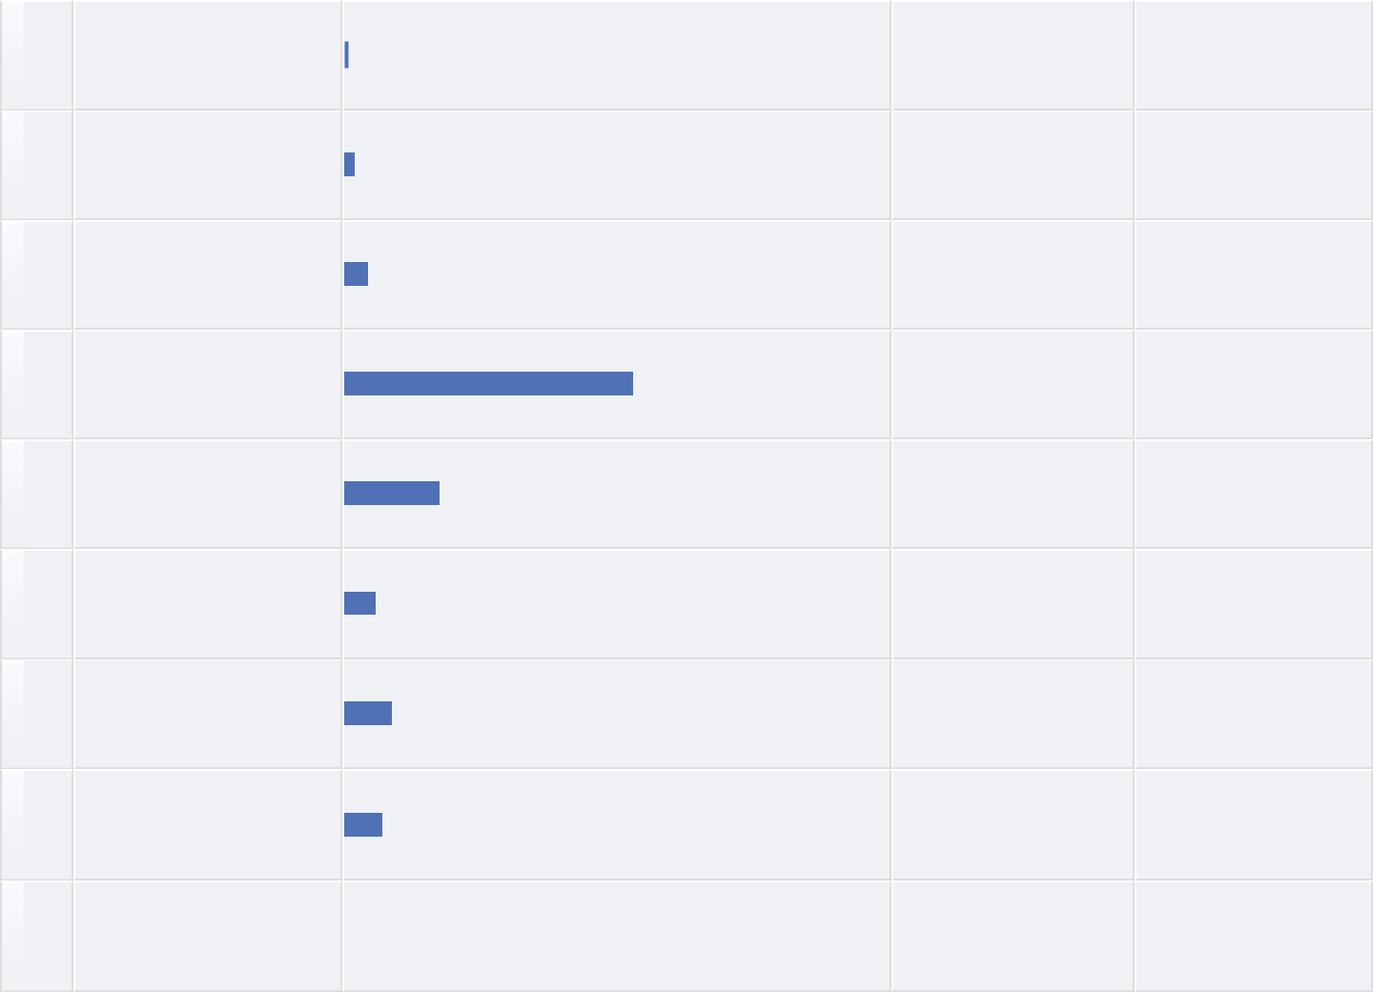

1 0.73%

3 2.19%

6 4.38%

73 53.28%

24 17.52%

8 5.84%

12 8.76%

10 7.30%

137 100.00%

**The following questions concern the parallel and poster sessions.**



**#** **Answer** **Bar** **Response** **%**



|  |  |  |  |
| --- | --- | --- | --- |
|  | Total | 0 | 100.00% |
|  |  |  |  |

**Are the parallel sessions too short or too long?**



* **Answer**
* 1: much too short

2 2

3 3

4 4

5 5

6 6

* 7: much too long

8no opinion

Total

**Bar** **Response** **%**

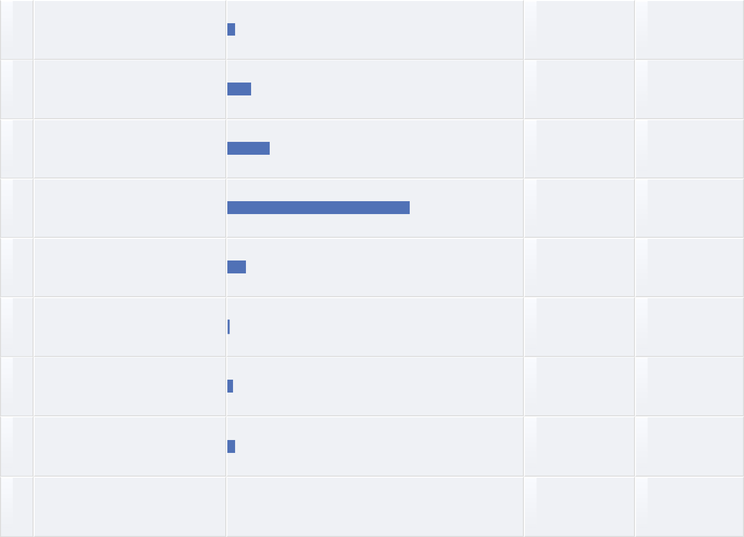

4 2.94%

11 8.09%

20 14.71%

84 61.76%

9 6.62%

1 0.74%

3 2.21%

4 2.94%

136 100.00%

**Should we have more or fewer parallel sessions?**



|  |  |  |  |  |  |  |  |  |  |  |  |
| --- | --- | --- | --- | --- | --- | --- | --- | --- | --- | --- | --- |
|  | **#** | **Answer** |  |  |  | **Bar** | | **Response** | **%** |  |  |
|  |  |  |  |  |  |
|  |  |  |  |  |  |  |  |  |  |  |  |
| 1 | | 1: fewer |  |  |  |  |  | 4 | 2.92% |  |  |
|  |  |  |  |  |  |  |
|  |  |  |  |  |  |  |  |  |  |  |  |
| 2 | | 3 |  |  |  |  |  | 4 | 2.92% |  |  |
|  |  |  |  |  |  |  |
|  |  |  |  |  |  |  |  |  |  |  |  |
| 3 | | 3 |  |  |  |  |  | 17 | 12.41% |  |  |
|  |  |  |  |  |  |  |
|  |  |  |  |  |  |  |  |  |  |  |  |
| 4 | | 4 |  |  |  |  |  | 66 | 48.18% |  |  |
|  |  |  |  |  |  |  |
|  |  |  |  |  |  |  |  |  |  |  |  |
| 5 | | 5 |  |  |  |  |  | 14 | 10.22% |  |  |
|  |  |  |  |  |  |  |
|  |  |  |  |  |  |  |  |  |  |  |  |
| 6 | | 6 |  |  |  |  |  | 8 | 5.84% |  |  |
|  |  |  |  |  |  |  |
|  |  |  |  |  |  |  |  |  |  |  |  |
| 7 | | 7: more |  |  |  |  |  | 15 | 10.95% |  |  |
|  |  |  |  |  |  |  |
|  |  |  |  |  |  |  |  |  |  |  |  |
| 8 | | no opinion |  |  |  |  |  | 9 | 6.57% |  |  |
|  |  |  |  |  |  |  |
|  |  | Total |  |  |  |  |  | 137 | 100.00% |  |  |
|  |  |  |  |  |  |  |  |  |
|  |  |  |  |  |  |  |  |  |  |  |  |



**How satisfied are you with the poster sessions?**



|  |  |  |  |  |  |  |  |  |  |  |  |  |
| --- | --- | --- | --- | --- | --- | --- | --- | --- | --- | --- | --- | --- |
|  | **#** | **Answer** |  |  |  |  |  | **Bar** | **Response** | **%** |  |  |
|  |  |  |  |  |  |  |  |
|  |  |  |  |  |  |  |  |  |  |  |  |  |
| 1 | | 1: very unsatisfied |  |  |  |  |  |  | 5 | 3.79% |  |  |
|  |  |  |  |  |  |  |  |
|  |  |  |  |  |  |  |  |  |  |  |  |  |
| 2 | | 2 |  |  |  |  |  |  | 6 | 4.55% |  |  |
|  |  |  |  |  |  |  |  |
|  |  |  |  |  |  |  |  |  |  |  |  |  |
| 3 | | 3 |  |  |  |  |  |  | 18 | 13.64% |  |  |
|  |  |  |  |  |  |  |  |
|  |  |  |  |  |  |  |  |  |  |  |  |  |
| 4 | | 4 |  |  |  |  |  |  | 22 | 16.67% |  |  |
|  |  |  |  |  |  |  |  |
|  |  |  |  |  |  |  |  |  |  |  |  |  |
| 5 | | 5 |  |  |  |  |  |  | 22 | 16.67% |  |  |
|  |  |  |  |  |  |  |  |
|  |  |  |  |  |  |  |  |  |  |  |  |  |
| 6 | | 6 |  |  |  |  |  |  | 24 | 18.18% |  |  |
|  |  |  |  |  |  |  |  |
|  |  |  |  |  |  |  |  |  |  |  |  |  |
| 7 | | 7: very satisfied |  |  |  |  |  |  | 25 | 18.94% |  |  |
|  |  |  |  |  |  |  |  |
|  |  |  |  |  |  |  |  |  |  |  |  |  |
| 8 | | no opinion |  |  |  |  |  |  | 10 | 7.58% |  |  |
|  |  |  |  |  |  |  |  |
|  |  | Total |  |  |  |  |  |  | 132 | 100.00% |  |  |
|  |  |  |  |  |  |  |  |  |  |
|  |  |  |  |  |  |  |  |  |  |  |  |  |



**If you could make any changes to the format of the poster sessions, what would those changes be?**



**Text Entry**



adequate

Organize them somewhat more according to topic if possible. Otherwise providing all posters online would be great.

difficult - maybe give presenters instructions on presentation requirements - many were way too small to see

Focus on specific poster areas each day. Only discovered some of the posters on the last day of the conference. A handout to indicate for each theme the title and abstact of the posters and their actual positions would assist to understand the variety of posters and better select the ones you are interested to see.

Not all posters had equal exposure, due to the location of the posters.

no changes

Last year in Boston the poster session was better, because the area was smaller. So everyone sirculated through all posters, whereas now many posters were in some remote corner where only a few people visited.

Some method to get people to visit more posters.

The poster sessions are great but difficult to absorb so much information in such a short time interval. Perhaps ISDC could increase number of concurrent parallel sessions while reducing the number of posters.

It was at the end of the day when participants were tired and hungry, so I would suggest to change timing and maybe in the morning when coffee is served is much better.

**View More**

**The following questions address the conference in a more general sense.**



**#** **Answer** **Bar** **Response** **%**



|  |  |  |  |
| --- | --- | --- | --- |
|  | Total | 0 | 100.00% |
|  |  |  |  |

**What is your opinion about the duration of the breaks during the conference?**



* **Answer**
* 1: too short

2 2

3 3

4 4

5 5

6 6

* 7: too long

8no opinion Total

**Bar** **Response** **%**

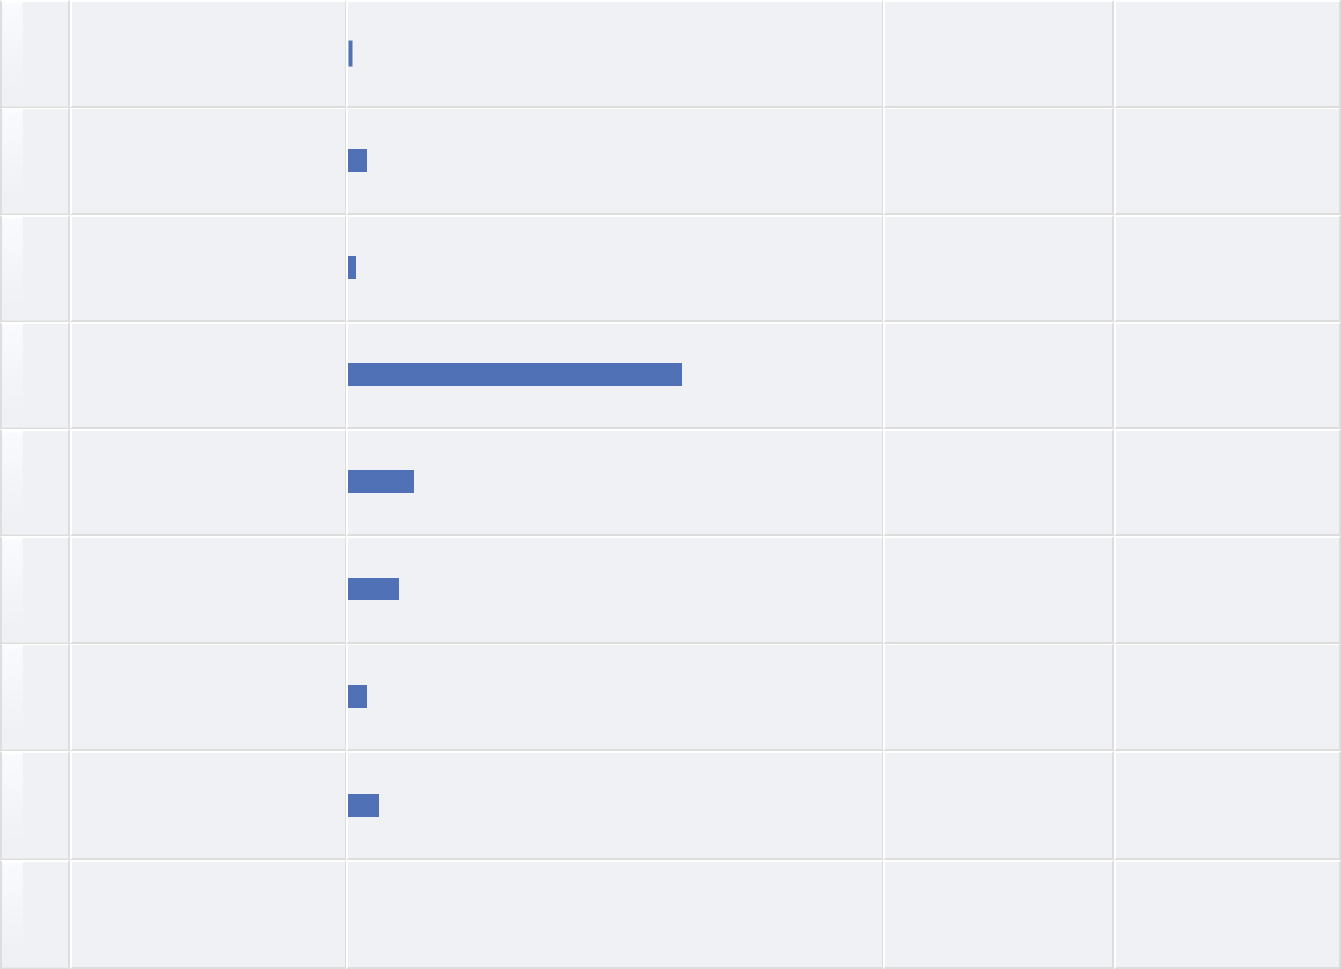

1 0.74%

5 3.68%

2 1.47%

85 62.50%

17 12.50%

13 9.56%

5 3.68%

8 5.88%

136 100.00%

**Would you like to see more or less academic work?**



|  |  |  |  |  |  |  |  |  |  |  |  |
| --- | --- | --- | --- | --- | --- | --- | --- | --- | --- | --- | --- |
|  | **#** | **Answer** |  |  |  |  | **Bar** | **Response** | **%** |  |  |
|  |  |  |  |  |  |  |
|  |  |  |  |  |  |  |  |  |  |  |  |
| 1 | | 1: less academic work |  |  |  |  |  | 5 | 3.68% |  |  |
|  |  |  |  |  |  |  |
|  |  |  |  |  |  |  |  |  |  |  |  |
| 2 | | 2 |  |  |  |  |  | 6 | 4.41% |  |  |
|  |  |  |  |  |  |  |
|  |  |  |  |  |  |  |  |  |  |  |  |
| 3 | | 3 |  |  |  |  |  | 7 | 5.15% |  |  |
|  |  |  |  |  |  |  |
|  |  |  |  |  |  |  |  |  |  |  |  |
| 4 | | 4 |  |  |  |  |  | 45 | 33.09% |  |  |
|  |  |  |  |  |  |  |
|  |  |  |  |  |  |  |  |  |  |  |  |
| 5 | | 5 |  |  |  |  |  | 21 | 15.44% |  |  |
|  |  |  |  |  |  |  |
|  |  |  |  |  |  |  |  |  |  |  |  |
| 6 | | 6 |  |  |  |  |  | 20 | 14.71% |  |  |
|  |  |  |  |  |  |  |
|  |  |  |  |  |  |  |  |  |  |  |  |
| 7 | | 7: more academic work |  |  |  |  |  | 27 | 19.85% |  |  |
|  |  |  |  |  |  |  |
|  |  |  |  |  |  |  |  |  |  |  |  |
| 8 | | no opinion |  |  |  |  |  | 5 | 3.68% |  |  |
|  |  |  |  |  |  |  |
|  |  | Total |  |  |  |  |  | 136 | 100.00% |  |  |
|  |  |  |  |  |  |  |  |  |
|  |  |  |  |  |  |  |  |  |  |  |  |



**How satisfied are you with the workshops?**



* **Answer**
* 1: very unsatisfied

2 2

3 3

4 4

5 5

6 6

* 7: very satisfied

8 no opinion

Total

**Bar** **Response** **%**

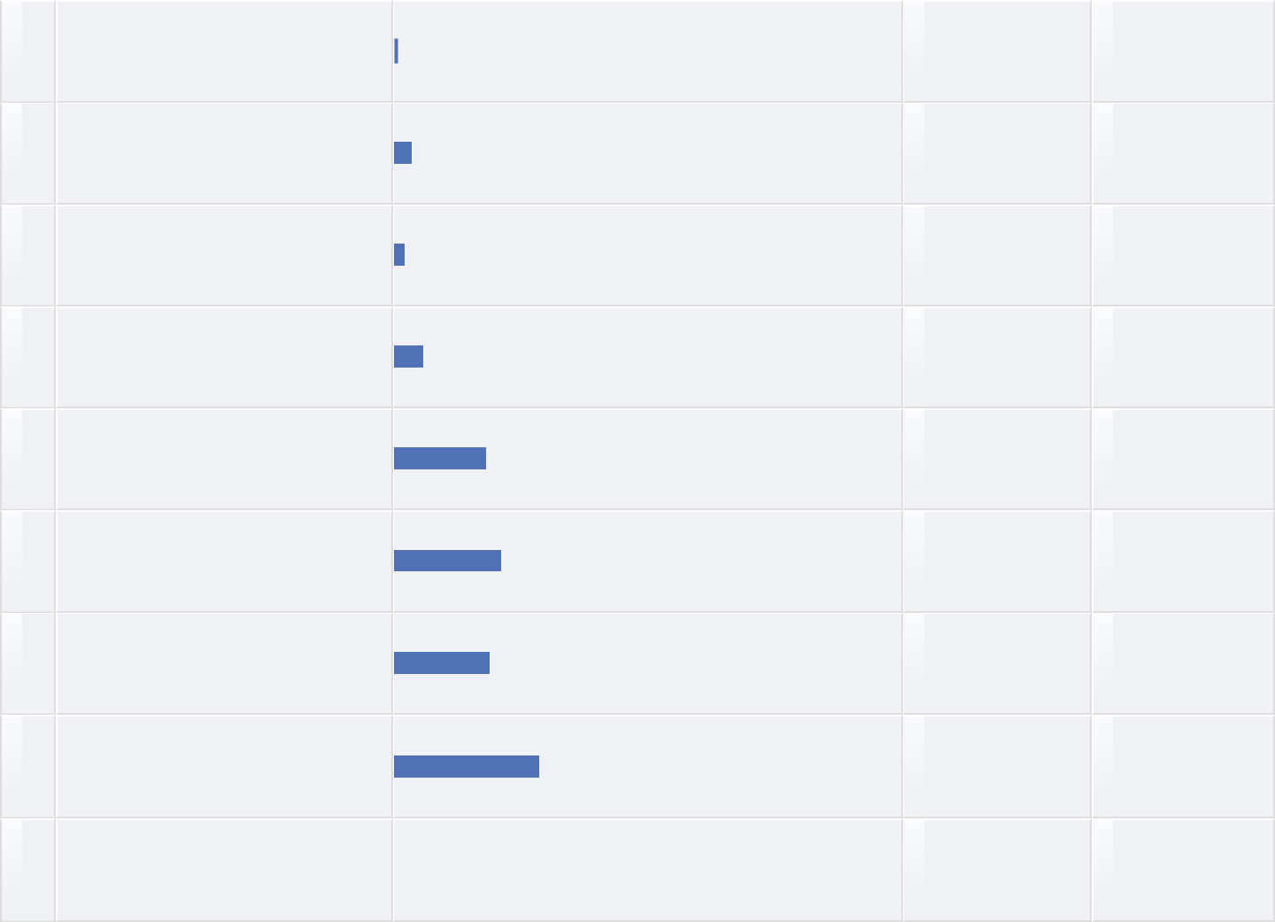

1 0.74%

5 3.68%

3 2.21%

8 5.88%

25 18.38%

29 21.32%

26 19.12%

39 28.68%

136 100.00%

**If you could make changes to the format of the workshops, what would those changes be?**



**Text Entry**



No comment

Workshops I attended was mainly presentations

There should have been two workshops. at the middle and at the end

The quality of the two workshops I attended was uneven. One was excellent. The other fell short because the presenters were not clear about the needs of the audience they had attracted.

Great workshops, thanks!

I gave a workshop. The room was not well organized for the workshop. It was overcrowded with tables, with almost no space to move around. The tech supervisor was very helpful. The projector and screen worked well.

methodology workshops were excellent. We need more methodology workshops perhaps sequenced throughout the conference. Some of the methodology workshops provide material on similar topics, all of which I would like to attend.

workshop handouts should be distributed after the workshop to all participants and online place for discussion about the workshop content should be made available for any followup q&a.

A more structured approach

I joined one. That was fine.

**View More**

**What, specifically, do you value about coming to the conference?**



**Text Entry**



The networking and contacts made and the openness and willingness to share knowledge.

Meeting serious researchers and young students with great ideas.

Time to interact with peers

Meeting professionals, learning from them, exhanging ideas. It helps understanding where we are and where we should go.

Good networking chance, some new ideas.

Building connections with the society members with in-person conversations.

Getting inspiration. Seeing old friends.

Learning about new work and connecting with others with similar interests who live far away from me.

Networking with other SD professionals, seeing what others from the academic community are researching

New and old dontacts, personal meetings, networking.

**View More**

**What was the best thing that happened to you at the conference?**



**Text Entry**



Getting to my scholars in the area of SD.

Meeting people that gave very concrete feedback on projects that I am working on. Experiencing how open-minded the community is, that you can approach everyone no matter what position and have helpful and insightful conversations.

Meeting the people I needed to accelerate my own SD model developments

nothing specific - all good

Listening to the talks given to PhD collequem participants on paper publishing and getting academic jobs.

Meeting high-honored system dynamicists by chance on the floor.

Agile SD

meeting people and friends

I meet Kaoru Yamaguchi

expanded network.

**View More**

**What was the worst thing that happened to you at the conference?**



**Text Entry**



None.

Missing out on meetings during lunch break, like the student chapter and business SIG.

Almost getting lost on the first day, while searching for the TPM building

no problems at all

Dinner on board the boat "The Queen". I am a vegetarian and I could hardy call what was provided as a decent meal leave alone calling it a banquet.

Nothing special

Food was not good especially from African perspective

none

couldn't attend all of the workshops I wanted to attend; disappointed in the Education SIG meeting.

I have no major complaints.

**View More**

**Background information**



**#** **Answer** **Bar** **Response** **%**



|  |  |  |  |
| --- | --- | --- | --- |
|  | Total | 0 | 100.00% |
|  |  |  |  |

**Profession**



**#** **Answer**

* Consulting
* Higher education
* In-house SD practitioner (private sector)

4 In-house SD practitioner (public sector)

5 K-12 education

6 Research using SD

7 SD client/ customer

8 Student Total

|  |  |  |  |  |
| --- | --- | --- | --- | --- |
| **Bar** | **Response** | **%** |  |  |
|  |  |
|  |  |  |  |  |
|  | 13 | 9.85% |  |  |
|  | 42 | 31.82% |  |  |
|  | 6 | 4.55% |  |  |
|  | 6 | 4.55% |  |  |
|  | 1 | 0.76% |  |  |
|  | 36 | 27.27% |  |  |
|  | 0 | 0.00% |  |  |
|  | 28 | 21.21% |  |  |
|  | 132 | 100.00% |  |  |

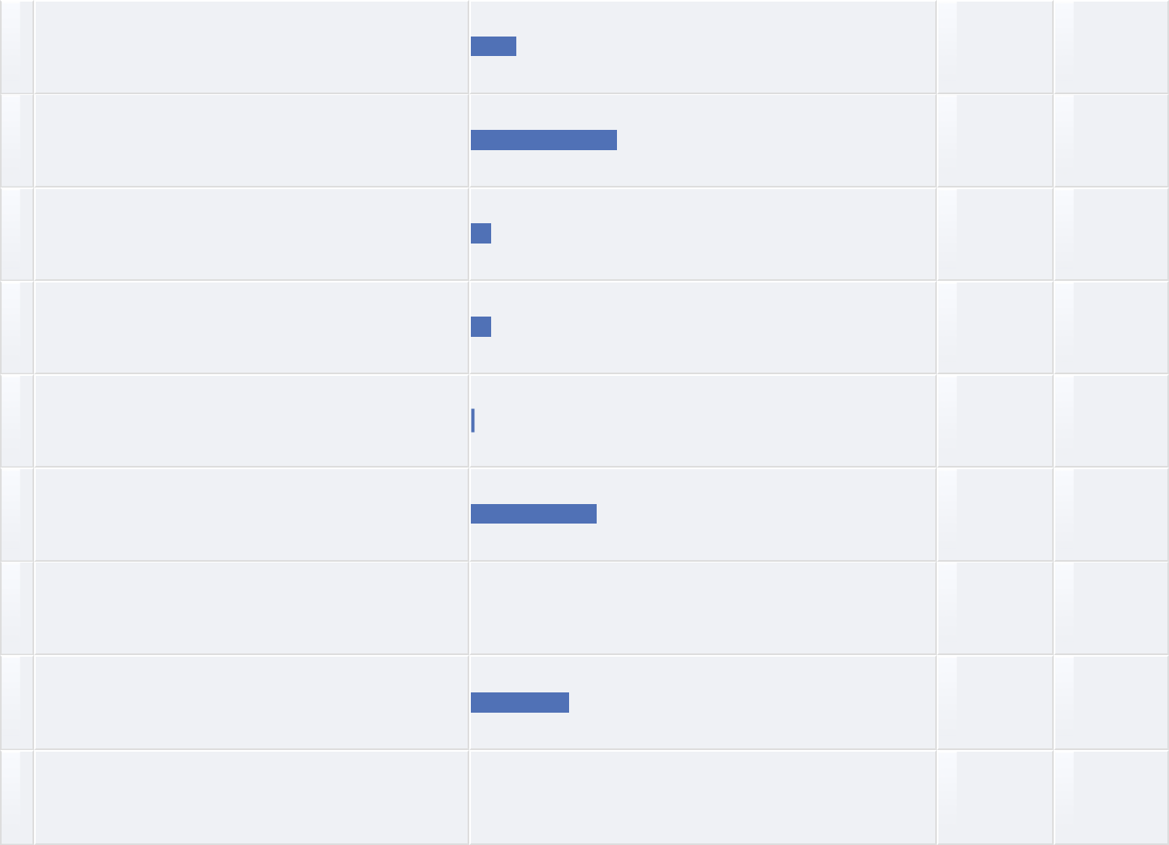

**Other (please specify)**



**Text Entry**



Parastatal - private company owned by the state

I do some public policy consulting as well as higher ed

I also provde training for instructors who want to use SD in their classrooms (for students ages 15 to 22)

and k-university education

Operation Planning & Management

I have taken a 10-week course in SD that covered only how to use Stella and very basic modeling. I am now working as an administrator in a University. I consider myself a student in SD.

Enterpreneur

Military Higher Education (Staff College)

Former SD student. Now just interested. I am not applying it currently.

Think tank (policy analysis institute), as well as PhD candidate

**View More**

**Fields of interest (please check all that apply)**



|  |  |  |  |  |  |  |  |  |  |  |  |  |  |  |  |  |  |
| --- | --- | --- | --- | --- | --- | --- | --- | --- | --- | --- | --- | --- | --- | --- | --- | --- | --- |
|  | **#** | **Answer** |  |  |  |  |  |  |  |  |  | **Bar** | | **Response** | **%** |  |  |
|  |  |  |  |  |  |  |  |  |  |  |  |
|  |  |  |  |  |  |  |  |  |  |  |  |  |  |  |  |  |  |
| 1 | | Business policy |  |  |  |  |  |  |  |  |  |  |  | 46 | 34.07% |  |  |
|  |  |  |  |  |  |  |  |  |  |  |  |  |
|  |  |  |  |  |  |  |  |  |  |  |  |  |  |  |  |  |  |
| 2 | | Teaching |  |  |  |  |  |  |  |  |  |  |  | 40 | 29.63% |  |  |
|  |  |  |  |  |  |  |  |  |  |  |  |  |
|  |  |  |  |  |  |  |  |  |  |  |  |  |  |  |  |  |  |
| 3 | | Strategy |  |  |  |  |  |  |  |  |  |  |  | 54 | 40.00% |  |  |
|  |  |  |  |  |  |  |  |  |  |  |  |  |
|  |  |  |  |  |  |  |  |  |  |  |  |  |  |  |  |  |  |
| 4 | | Health |  |  |  |  |  |  |  |  |  |  |  | 26 | 19.26% |  |  |
|  |  |  |  |  |  |  |  |  |  |  |  |  |
|  |  |  |  |  |  |  |  |  |  |  |  |  |  |  |  |  |  |
| 5 | | Economic dynamics |  |  |  |  |  |  |  |  |  |  |  | 44 | 32.59% |  |  |
|  |  |  |  |  |  |  |  |  |  |  |  |  |
|  |  |  |  |  |  |  |  |  |  |  |  |  |  |  |  |  |  |
| 7 | | Energy and resources |  |  |  |  |  |  |  |  |  |  |  | 49 | 36.30% |  |  |
|  |  |  |  |  |  |  |  |  |  |  |  |  |
|  |  |  |  |  |  |  |  |  |  |  |  |  |  |  |  |  |  |
| 8 | | Environment and ecology |  |  |  |  |  |  |  |  |  |  |  | 50 | 37.04% |  |  |
|  |  |  |  |  |  |  |  |  |  |  |  |  |
|  |  |  |  |  |  |  |  |  |  |  |  |  |  |  |  |  |  |
| 9 | | Information science |  |  |  |  |  |  |  |  |  |  |  | 17 | 12.59% |  |  |
|  |  |  |  |  |  |  |  |  |  |  |  |  |
|  |  |  |  |  |  |  |  |  |  |  |  |  |  |  |  |  |  |
| 10 | | Methodology |  |  |  |  |  |  |  |  |  |  |  | 65 | 48.15% |  |  |
|  |  |  |  |  |  |  |  |  |  |  |  |  |
|  |  | Operations management and supply |  |  |  |  |  |  |  |  |  |  |  |  |  |  |  |
| 11 | |  |  |  |  |  |  |  |  |  |  |  | 31 | 22.96% |  |  |
|  |  |  |  |  |  |  |  |  |  |  |  |  |
| chains |  |  |  |  |  |  |  |  |  |  |  |  |  |
|  |  |  |  |  |  |  |  |  |  |  |  |  |
|  | |  |  |  |  |  |  |  |  |  |  |  |  |  |  |  |  |
| 12 | | Participatory problem solving |  |  |  |  |  |  |  |  |  |  |  | 37 | 27.41% |  |  |
|  |  |  |  |  |  |  |  |  |  |  |  |  |
|  |  |  |  |  |  |  |  |  |  |  |  |  |  |  |  |  |  |
| 13 | | Public policy |  |  |  |  |  |  |  |  |  |  |  | 60 | 44.44% |  |  |
|  |  |  |  |  |  |  |  |  |  |  |  |  |
|  |  |  |  |  |  |  |  |  |  |  |  |  |  |  |  |  |  |
| 14 | | Security |  |  |  |  |  |  |  |  |  |  |  | 14 | 10.37% |  |  |
|  |  |  |  |  |  |  |  |  |  |  |  |  |
|  |  |  |  |  |  |  |  |  |  |  |  |  |  |  |  |  |  |
| 15 | | Social and organizational dynamics |  |  |  |  |  |  |  |  |  |  |  | 39 | 28.89% |  |  |
|  |  |  |  |  |  |  |  |  |  |  |  |  |
|  |  | Total |  |  |  |  |  |  |  |  |  |  |  | 572 | 100.00% |  |  |
|  |  |  |  |  |  |  |  |  |  |  |  |  |  |  |
|  |  |  |  |  |  |  |  |  |  |  |  |  |  |  |  |  |  |



**How often have you attended the SD conference before?**



**#** **Answer** **Bar** **Response** **%**



|  |  |  |  |  |  |  |  |  |
| --- | --- | --- | --- | --- | --- | --- | --- | --- |
| 1 | Never, this was the first time I visited the |  |  |  |  | 47 | 34.56% |  |
|  |  |  |  |  |
| SD conference |  |  |  |  |  |
|  |  |  |  |  |
|  |  |  |  |  |  |  |  |  |
| 2 | 1 time before |  | 17 | | | | 12.50% |  |
|  |  |
|  |  |  |  |  |  |  |  |  |
| 3 | 2-5 times before |  | |  | 37 | | 27.21% |  |
|  | |  |  |
|  |  |  |  |  |  |  |  |  |
| 4 | 6 times or more |  | | 35 | | | 25.74% |  |
|  | |  |
|  | Total | 136 | | | | | 100.00% |  |
|  |  |
|  |  |  |  |  |  |  |  |  |



**Other (please specify)**



**Text Entry**



I think that many of the plenary talks could have been improved with some additional coaching from chairs. I know that they must have submitted/done outstanding work but much of that was lost in their presentations. Perhaps the presenters did not know which parts to highlight and needed some help.

It would be nice to have a plenary talk for each thread.

Fields of Interest missing: Psychology (Human Behavior)

**Residence**



* **Answer**
* Africa
* Asia
* Europe
* South America

5Central America

6North America

7Ocenia Total

**Bar** **Response** **%**

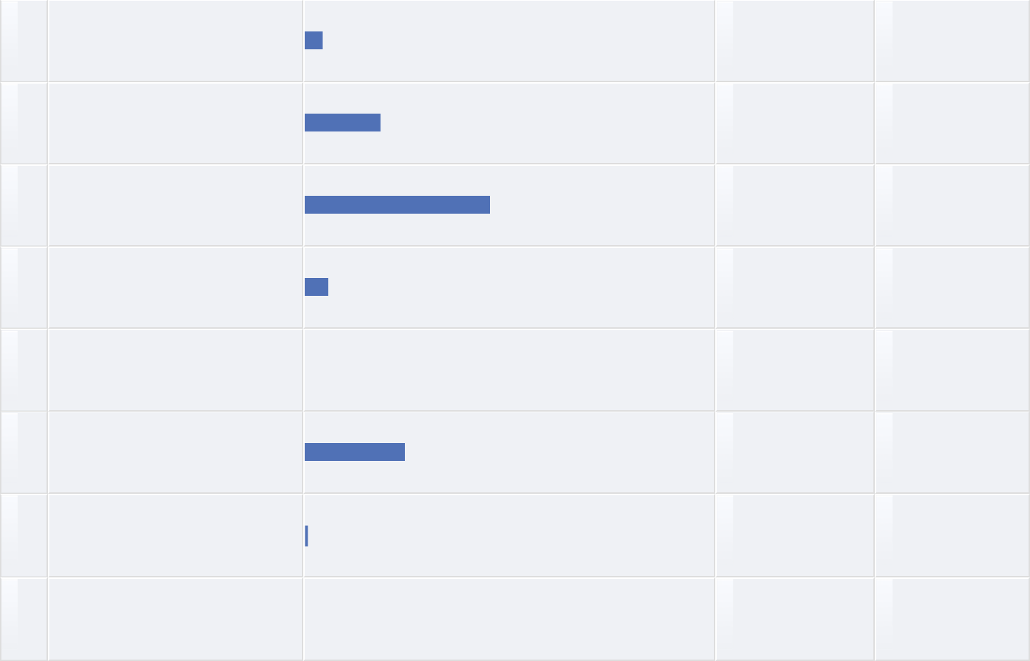

6 4.48%

25 18.66%

61 45.52%

8 5.97%

0 0.00%

33 24.63%

1 0.75%

134 100.00%

**Other (please specify)**



**Text Entry**



Onited Kingdom

Middle East

Korea

**Years as a system dynamicist (student)**



**Text Entry**



5

1

* years
* years

5

10

4

6

**View More**

**Years as a system dynamicist (practitioner)**



**Text Entry**



5

0

2

20+

5

over 5 years

* year None 2 2

**View More**

**An idea that is considered for future conferences, is to make the conference schedule available using a smartphone app. For that reason, we would like to ask you if you own a smartphone.**



**#** **Answer** **Bar** **Response** **%**



|  |  |  |  |  |  |  |
| --- | --- | --- | --- | --- | --- | --- |
| 1 | Yes, I own a smartphone |  |  | 117 | 86.67% |  |
|  |  |  |
|  |  |  |  |  |  |  |
| 2 | No, I do not own a smartphone |  | 18 | | 13.33% |  |
|  |  |
|  | Total | 135 | | | 100.00% |  |
|  |  |
|  |  |  |  |  |  |  |



**Have you used the Conference Online Scheduler?**



|  |  |  |  |  |  |  |  |  |
| --- | --- | --- | --- | --- | --- | --- | --- | --- |
|  | **#** | **Answer** |  | **Bar** | **Response** | **%** |  |  |
|  |  |  |  |
|  |  |  |  |  |  |  |  |  |
| 1 | | Yes |  |  | 50 | 37.31% |  |  |
|  |  |  |  |
|  |  |  |  |  |  |  |  |  |
| 2 | | No |  |  | 84 | 62.69% |  |  |
|  |  |  |  |
|  |  | Total |  |  | 134 | 100.00% |  |  |
|  |  |  |  |  |  |
|  |  |  |  |  |  |  |  |  |



**If you have used the Conference Online Scheduler, which device have you used? Please check all that apply.**



|  |  |  |  |  |  |  |  |  |  |  |  |
| --- | --- | --- | --- | --- | --- | --- | --- | --- | --- | --- | --- |
|  | **#** | **Answer** |  |  |  | **Bar** | | **Response** | **%** |  |  |
|  |  |  |  |  |  |
|  |  |  |  |  |  |  |  |  |  |  |  |
| 1 | | Computer |  |  |  |  |  | 35 | 56.45% |  |  |
|  |  |  |  |  |  |  |
|  |  |  |  |  |  |  |  |  |  |  |  |
| 2 | | Smartphone Wifi |  |  |  |  |  | 29 | 46.77% |  |  |
|  |  |  |  |  |  |  |
|  |  |  |  |  |  |  |  |  |  |  |  |
| 3 | | Smartphone 3/4G |  |  |  |  |  | 11 | 17.74% |  |  |
|  |  |  |  |  |  |  |
|  |  |  |  |  |  |  |  |  |  |  |  |
| 4 | | Tablet Wifi |  |  |  |  |  | 20 | 32.26% |  |  |
|  |  |  |  |  |  |  |
|  |  |  |  |  |  |  |  |  |  |  |  |
| 5 | | Tablet 3/4G |  |  |  |  |  | 2 | 3.23% |  |  |
|  |  |  |  |  |  |  |
|  |  | Total |  |  |  |  |  | 97 | 100.00% |  |  |
|  |  |  |  |  |  |  |  |  |
|  |  |  |  |  |  |  |  |  |  |  |  |



**Any other comments you may have**



**Text Entry**



Thanks for the great work, the conference was very helpful for my current activities and provided insight to a lot of unanswered questions about the field. Also for the survey, very thorough and good to recap for oneself. Keep up the good work!

another wonderful event - thank you so much

An app for the conference schedule is a very good idea!

Great conference overall, apart from Roberta's accident. The organizers did a great job. thanks for soliciting such detailed feedback. With best wishes. John Richardson

I am unsure what you mean by the Conference Online Scheduler - I am assuming this refers to looking at the conference schedule online, by thread and by day.

Please include lunch (cost I mean) in the conference registration fee.

Nice job--a very informative meeting.

i wasnt really aware of online scheduler option

Pleanary presentations should inspire us. Therefore, the work and the presenter should carefully be selected.

wish Roberta well

**View More**